STATS 401: Data Acquisition and Visualization
Individual Project – Visualization Critique and Redesign
Visualization Critique and Redesign Report
Muhammad Anas Tahir
September 26, 2026

Original Visualization and Context
This project critiques the Finviz S&P 500 Map, a treemap on finviz.com that displays every company in the S&P 500 index. Each company appears as a tile grouped by sector and industry. Tile size encodes market capitalization, and tile color encodes the day's percent change in stock price, green for gains and red for losses. The map updates throughout each trading day from live market data; the screenshot in this report was captured on September 24, 2026 (Finviz, n.d.).
The intended message is to summarize how the market performed on a given day, across the index as a whole and within each sector, drawing attention to which sectors led gains or losses and which companies moved the most. The intended audience is active traders and casual market watchers who want a fast visual read of the day's action rather than a table of numbers. The main tasks it supports are scanning for the biggest movers, comparing sectors at a glance, and forming a quick sense of overall market sentiment.
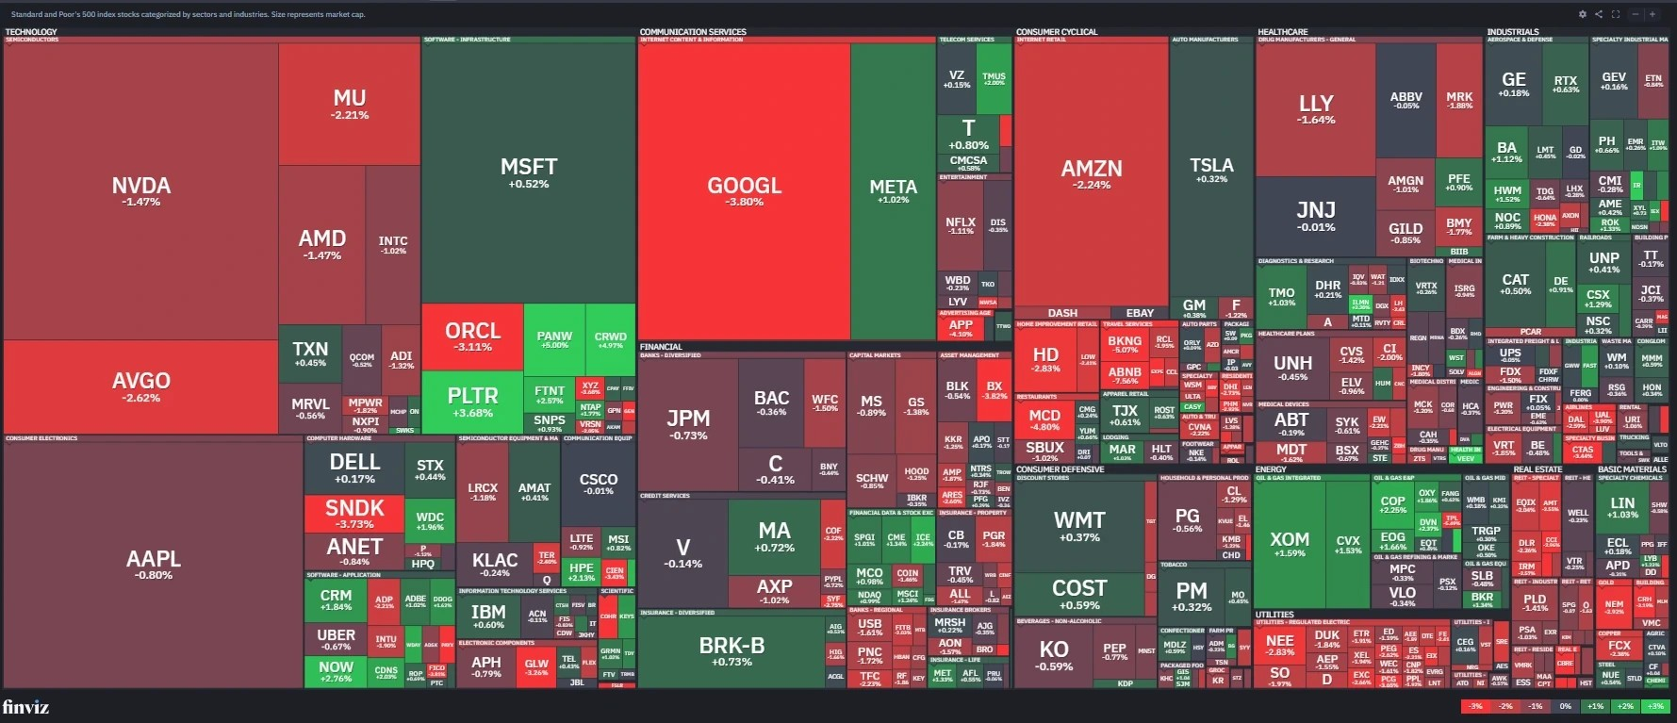
Figure 1: Finviz S&P 500 Map.
Source: https://finviz.com/map (screenshot, September 24th, 2026)

Critique

Strengths
- Density. The map fits the entire index onto one screen, so a viewer can scan hundreds of companies at once instead of paging through spreadsheets.
- Hierarchy. Grouping tiles by sector and industry gives the layout clear structure, so a viewer can find a company alongside its broader context.

Weaknesses
- Competing channels. Tile size and tile color carry two different variables, market capitalization and daily change, and only color carries the day's real message. Area draws the eye more strongly than color (Harley & Kaley, 2019), so attention lands on the biggest companies rather than the biggest movers. The fix is to give change its own dedicated channel.
- Imprecise color. A viewer can tell a tile is red, but not whether it fell half a percent or three percent, without hovering over it, which matters for a chart built around comparing performance. The fix is to pair color with a precise channel such as length, plus a text label.
- Cap-weighting distortion. Because tile size is market capitalization, a handful of giant companies can make the whole map look uniformly green or red even when most smaller companies moved the opposite way. The fix is to also report an equal weighted view.

Redesign Rationale
The redesign is a linked pair of views built with D3.js, shown in Figures 2 and 3: hover a sector, click to drill into its companies, or switch the toggles, and both views respond.
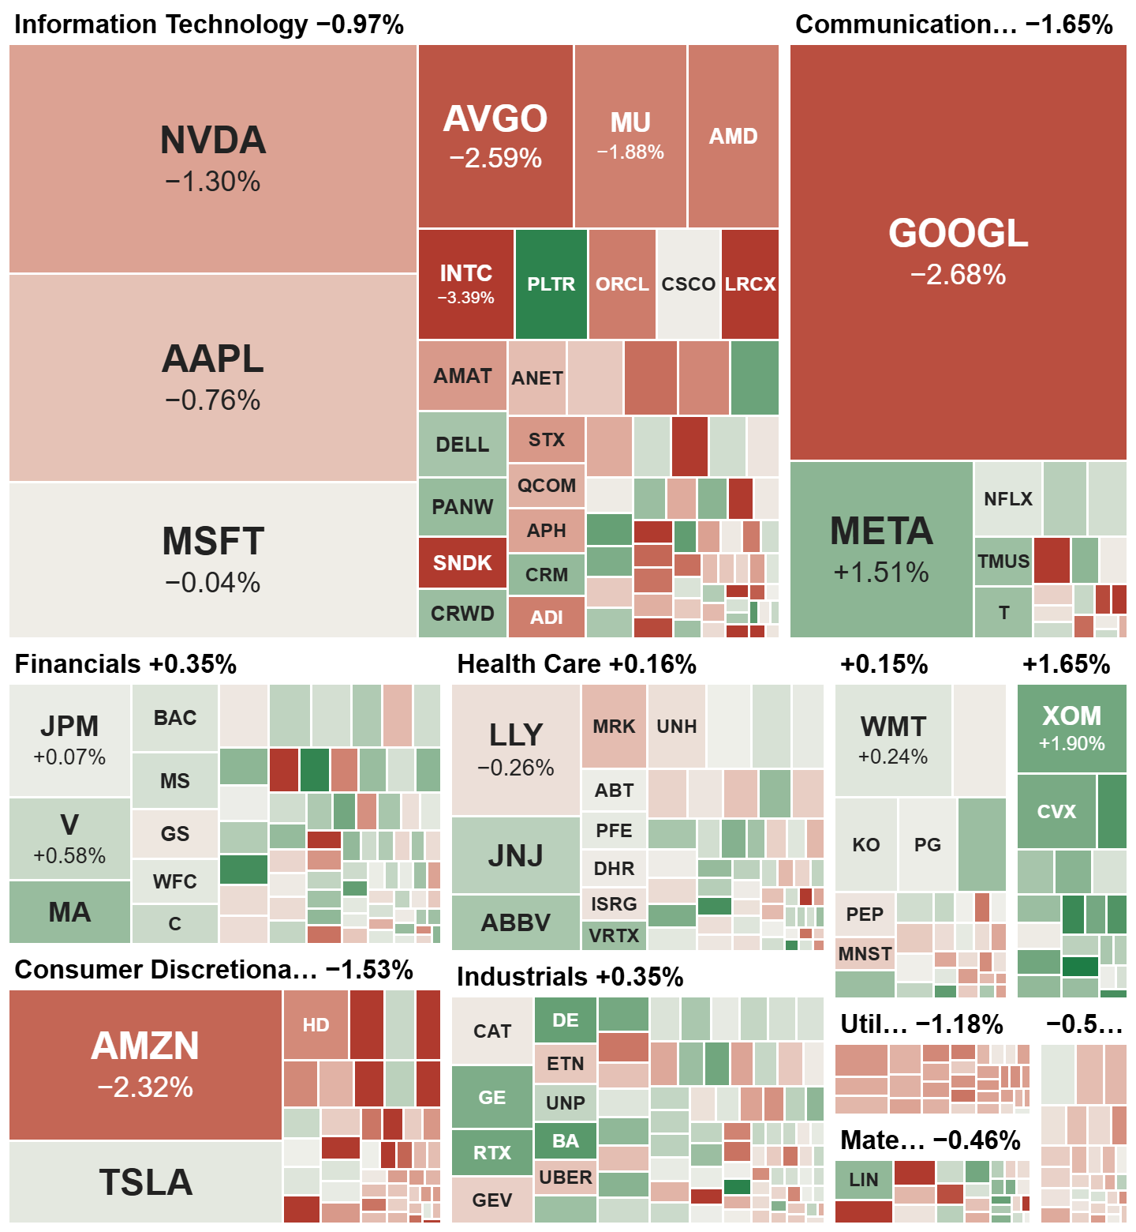
Figure 2: Market Cap by Sector.
Redesigned treemap. Tile area is market capitalization, grouped by GICS sector; tile color reinforces daily percent change. Author's D3.js redesign, S&P 500 snapshot retrieved September 24, 2026.
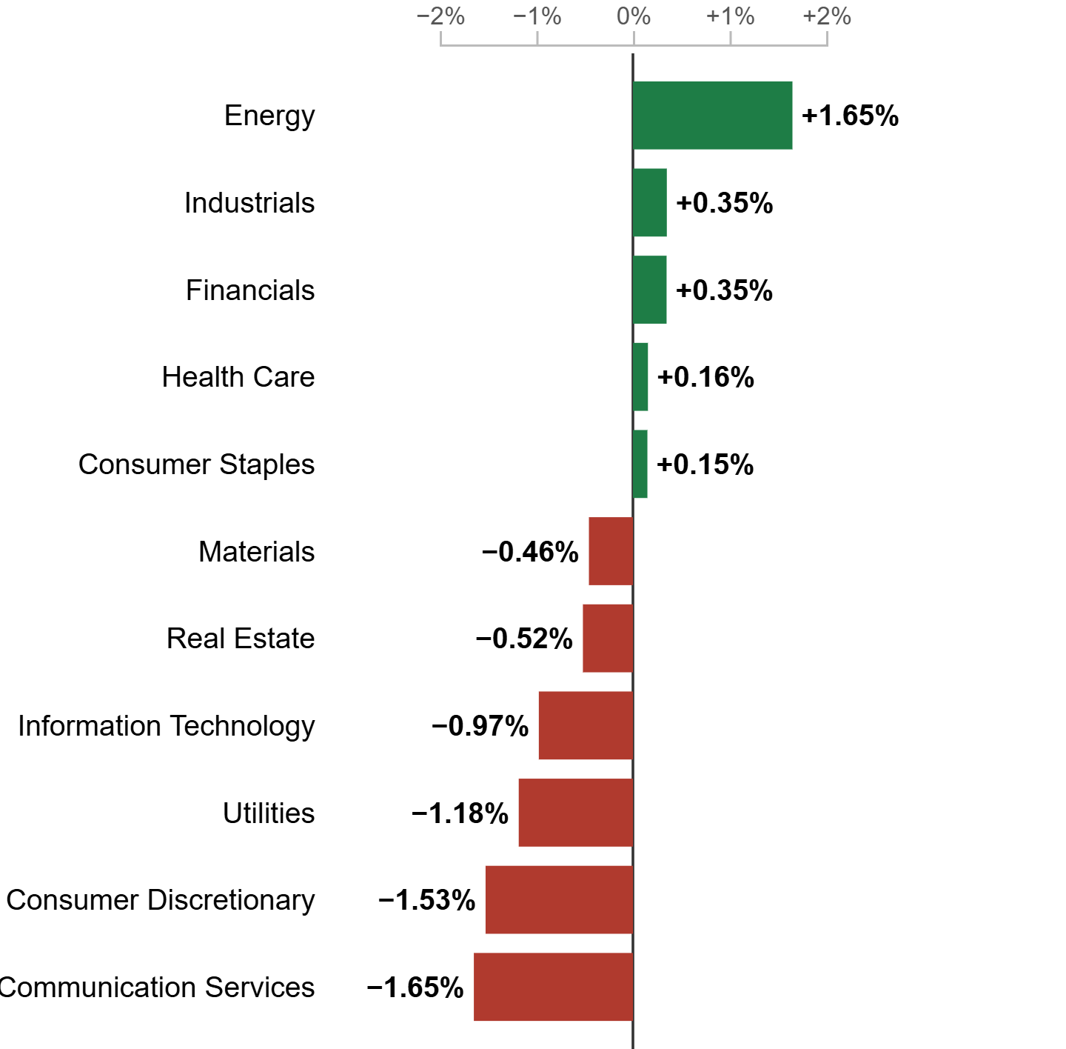
Figure 3: Ranked Sector Change.
Daily percent change on bar length and position from a zero line, ranked from best to worst performing sector, linked to Figure 2. Author's D3.js redesign, S&P 500 snapshot retrieved September 24, 2026.
The first pair of changes fixes how change is read. Daily percent change moves off tile color and onto bar length and position along a zero-centered axis. This addresses the competing channels problem by giving change a precise, dedicated channel where a viewer can rank sectors and companies rather than sensing direction from a color. Once change had its own channel, color no longer needed to carry precise information. Every bar is recolored with a single flat green or red instead of a gradient, which fixes the imprecise color problem as well. Color now marks sign only and never repeats what bar length already shows.
The remaining two changes fix how a market-wide move is summarized. A toggle between cap-weighted and equal-weighted sector averages, paired with a breadth summary of advancers and decliners, addresses the cap-weighting distortion. A viewer can confirm whether a move is broad-based or driven by a handful of large companies, rather than relying on one headline number. The compare panel, shown in Figure 4, extends that idea to individual companies. A viewer searches for any company and adds it to a shared chart, so companies from different sectors sit on one axis. This supports a task the original design cannot do at all, comparing specific companies directly instead of scanning the whole map. It reuses the same flat colors and signed labels as the sector chart.
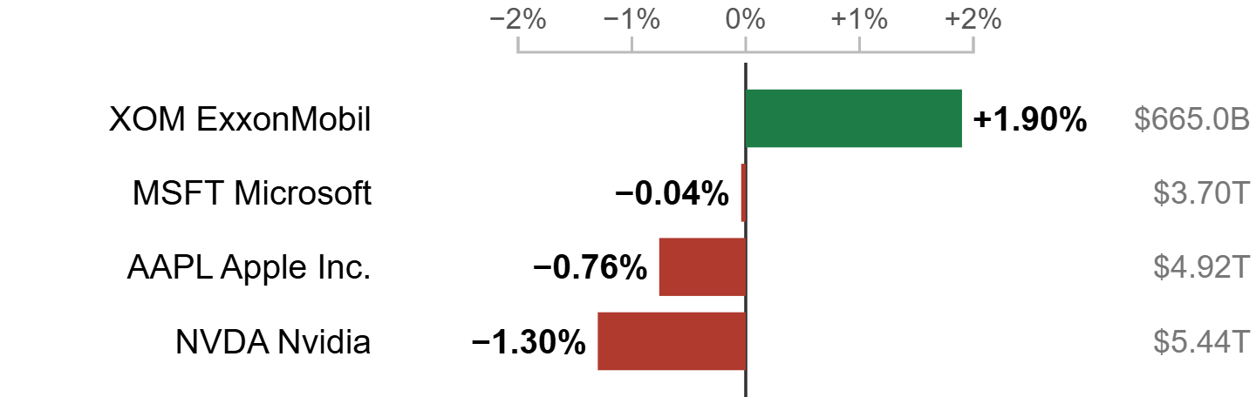
Figure 4: Compare Any Companies Panel.
Example comparison: ExxonMobil (Energy) alongside Microsoft, Apple, and Nvidia (Information Technology) on one shared axis, added through the searchable dropdown. Author's D3.js redesign, S&P 500 snapshot retrieved September 24, 2026.

Original vs. Redesign
Four changes separate the redesign from the original, each mapped to a weakness identified above. Daily percent change moved from tile color to bar length and position, so a viewer reads and ranks performance directly rather than judging it by a color's intensity. Bar color changed from a continuous gradient to a single flat green or red, removing the redundant encoding that had two channels competing for the same message. A weight toggle and breadth summary let a viewer see the cap-weighted number the index reports alongside the equal-weighted number that reflects the typical company, surfacing cases where the two diverge. Finally, the compare panel adds a task the original visualization never supported, placing any selection of companies from different sectors on one shared axis instead of hunting across the map.
Together these changes make ranking and precise comparison much easier. A viewer can see immediately which sector moved the most and confirm whether that move was broad-based or driven by a few large companies. The original only supported that by scanning for color intensity. The trade-off is density. The original shows all five hundred companies on one screen, while the redesign asks a viewer to drill into a sector to see individual companies.

Data Sources and References
- Finviz. (n.d.). S&P 500 Map. Finviz.com. finviz.com/map
- Harley, K., & Kaley, A. (2019). Treemaps: Data Visualization of Complex Hierarchies. Nielsen Norman Group. nngroup.com/articles/treemaps
- Nasdaq. Stock Screener market data (market cap, price, daily change). Accessed 24 Sept. 2026 via github.com/zyhe16/top-us-stock-tickers (MIT-licensed mirror).
- Wikipedia contributors. List of S&P 500 companies (GICS sectors). Accessed 24 Sept. 2026 via the datahub package (ODC PDDL).
- Redesign data file: sp500_snapshot.json, built with D3.js v7. Full build and code: muhammadanastahir.github.io/stats401-labs

